**-22AIE303-  
Database management systems**

# **Labsheet – 5**

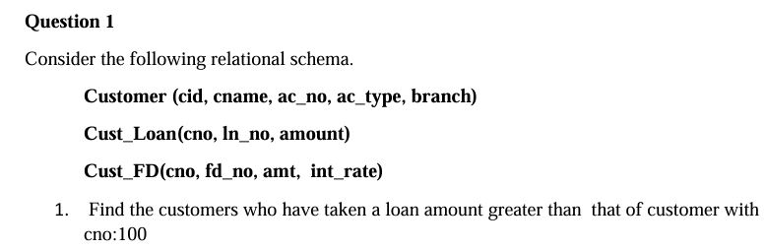  
**Customer Table**

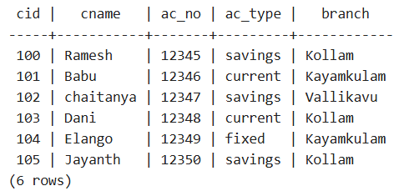  
**Cust_Loan Table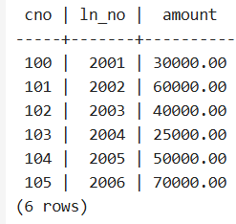 Cust_FD Table**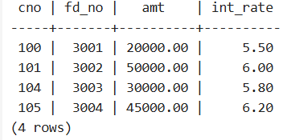

-- 1. Find customers who have taken a loan amount greater than that of customer with cno=100

SELECT cname FROM Customer

WHERE cid IN (SELECT cno FROM Cust_Loan WHERE amount > (SELECT amount FROM Cust_Loan WHERE cno = 100));

  


-- 2. List the names of all customers who have taken a loan > 50000

SELECT cname FROM Customer

WHERE cid IN (SELECT cno FROM Cust_Loan WHERE amount > 50000);

  


-- 3. Find names of all customers who have the same account type as customer 'James'

SELECT cname FROM Customer

WHERE ac_type = (SELECT ac_type FROM Customer WHERE cname = 'Jayanth');

  


-- 4. List the names of all customers who do not have a fixed deposit

SELECT cname FROM Customer

WHERE cid NOT IN (SELECT cno FROM Cust_FD);

  


-- 5. Find the name of the customer having the highest FD amount

SELECT cname FROM Customer

WHERE cid = (SELECT cno FROM Cust_FD WHERE amt = (SELECT MAX(amt) FROM Cust_FD));

  


-- 6. Find the names of customers who have taken at least one loan

SELECT cname FROM Customer

WHERE cid IN (SELECT cno FROM Cust_Loan);



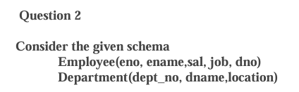  
**Employee Table  
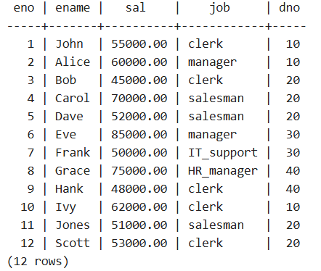  
Department Table  
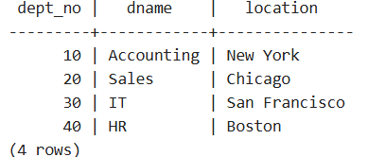  
**

-- 1. Display the name of the employee who earns the highest salary

SELECT ename FROM Employee

WHERE sal = (SELECT MAX(sal) FROM Employee);





-- 2. Display the employee number and name for employee working as clerk and earning highest salary among clerks

SELECT eno, ename FROM Employee

WHERE job = 'clerk' AND sal = (SELECT MAX(sal) FROM Employee WHERE job = 'clerk');

**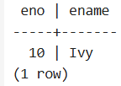  
**

-- 3. Display the names of salesmen who earn a salary more than the highest salary of any clerk

SELECT ename FROM Employee

WHERE job = 'salesman' AND sal > (SELECT MAX(sal) FROM Employee WHERE job = 'clerk');

**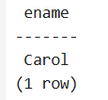  
**

-- 4. Display the names of clerks who earn a salary more than the lowest salary of any salesman

SELECT ename FROM Employee

WHERE job = 'clerk' AND sal > (SELECT MIN(sal) FROM Employee WHERE job = 'salesman');

**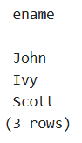  
**

-- 5. Display the names of employees who earn a salary more than that of Jones or greater than that of Scott

SELECT ename FROM Employee

WHERE sal > (SELECT sal FROM Employee WHERE ename = 'Jones')

   OR sal > (SELECT sal FROM Employee WHERE ename = 'Scott');

**  
**

-- 6. Display the names of the employees who earn the highest salary in their respective departments

SELECT ename FROM Employee

WHERE sal = (SELECT MAX(sal) FROM Employee WHERE dno = Employee.dno);

**  
**

-- 7. Display the names of the employees who earn the highest salaries in their respective job groups

SELECT ename FROM Employee

WHERE sal = (SELECT MAX(sal) FROM Employee WHERE job = Employee.job);